La Grange Reach

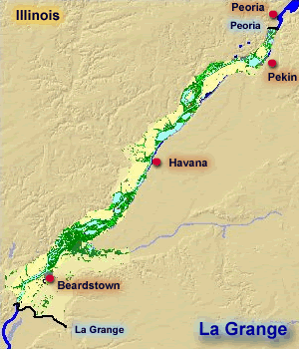

Data Collection

User Guide

University of Missouri - St. Louis

SP17- CMPSCI4500-001

Professor Keith Miller

|  |  |
| --- | --- |
| Jason Klamert | Charlotte Kawa |

|  |  |  |
| --- | --- | --- |
| Marwa Alzori | Rebecca Dolph | Paul Donnelly |
| Tim Galvin | Tiffany O’Connell | Harprabh Sangha |

Gathering Your River Gauge Data

Before you can visualize your river data, you must collect it. This program has been designed to run with historical data obtained from the National Weather Service. These step by step instructions will show you how and where to get the data for your chosen river gauge.

1. Navigate to the [water.weather.gov](http://water.weather.gov/ahps/) website.

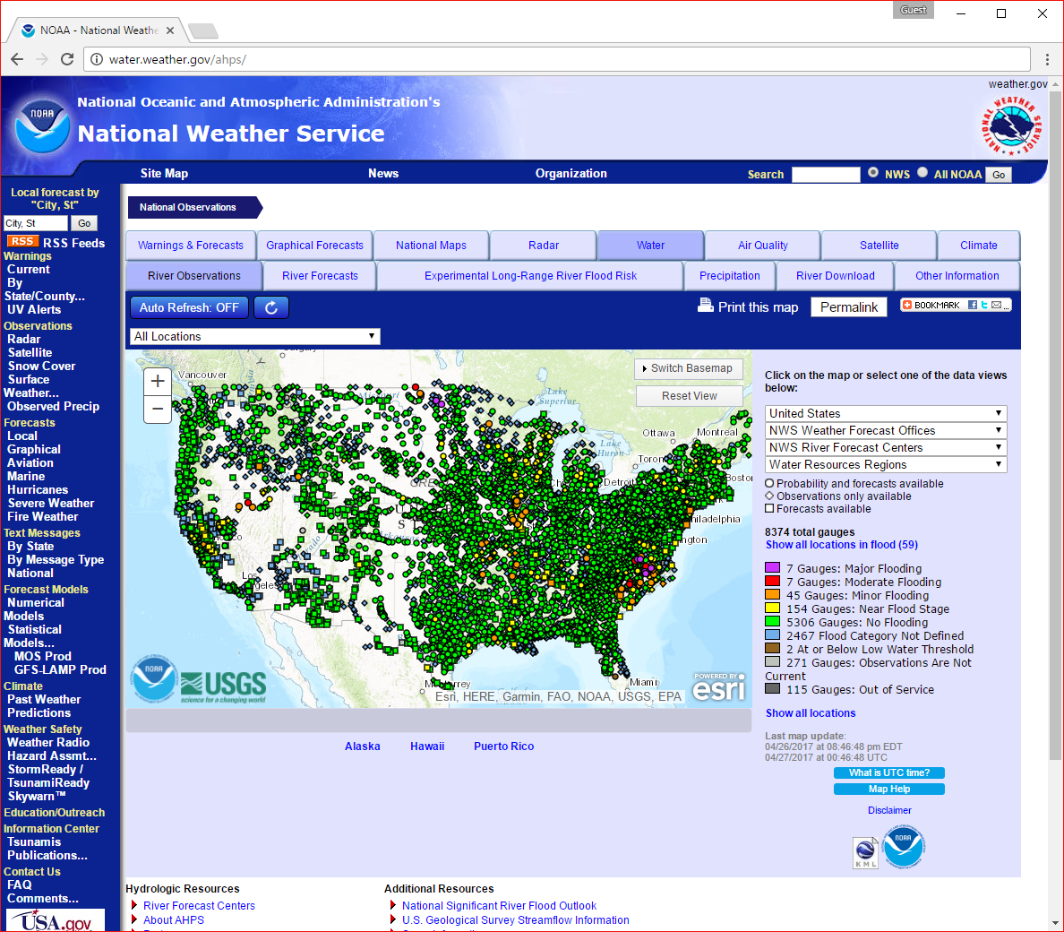

1. Zoom in on the map in the area of your desired river gauge, then click on a dot/square in that area.

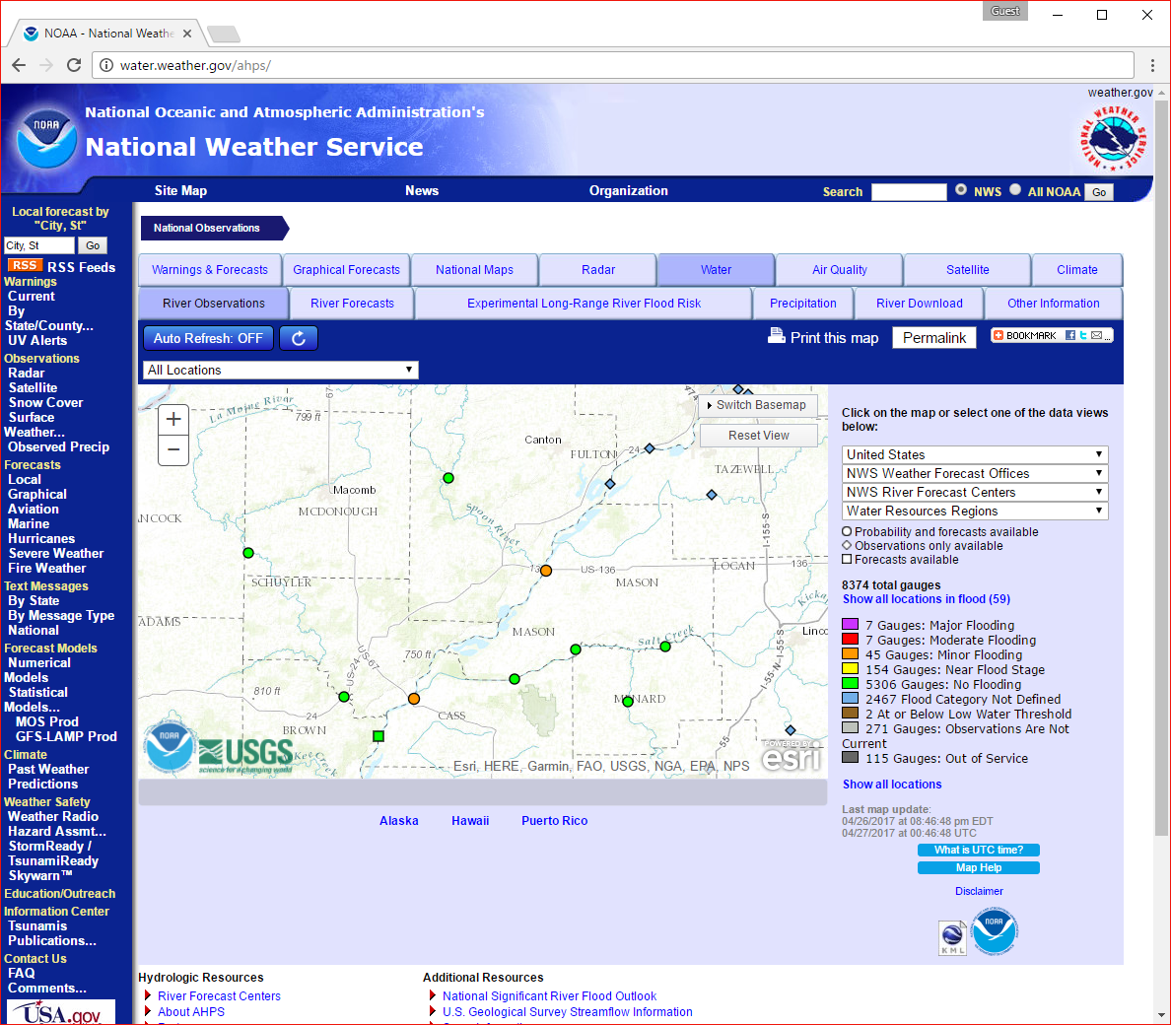

1. Feel free to zoom in on the newly loaded map. Click on the dot/square of the desired gauge. (If you start at one end of your data area, you will be able to click an upstream/downstream gauge button to easily switch stations).

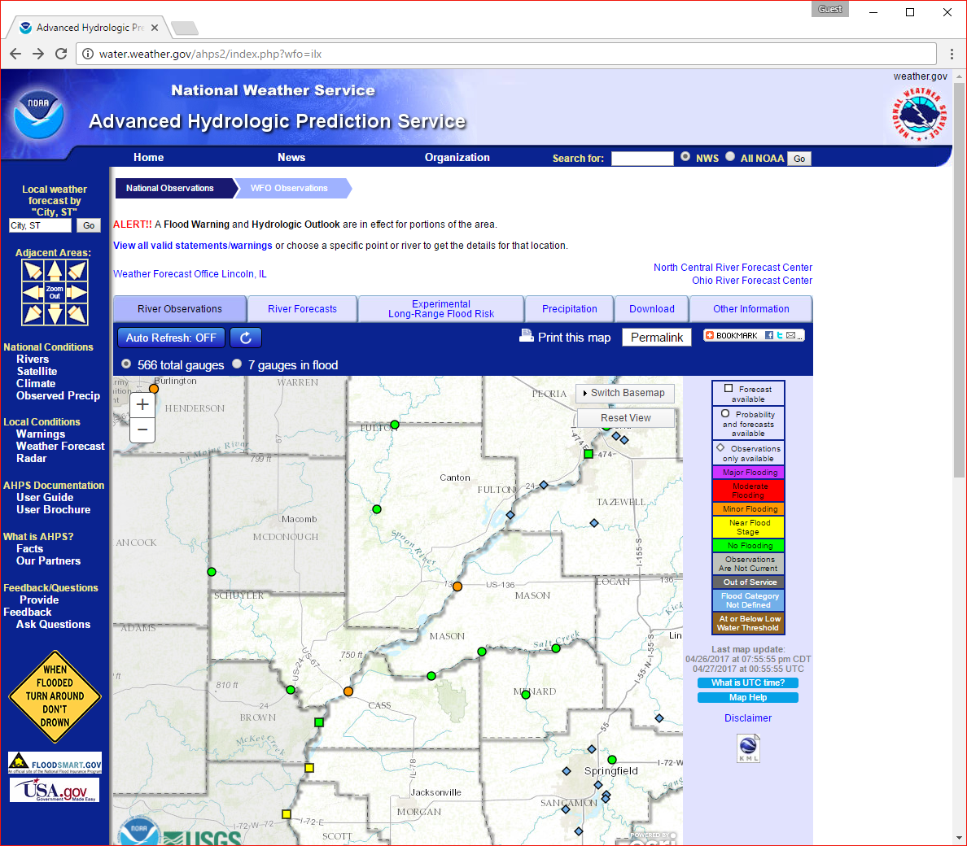

1. Scroll down to Current/Historical Observations.

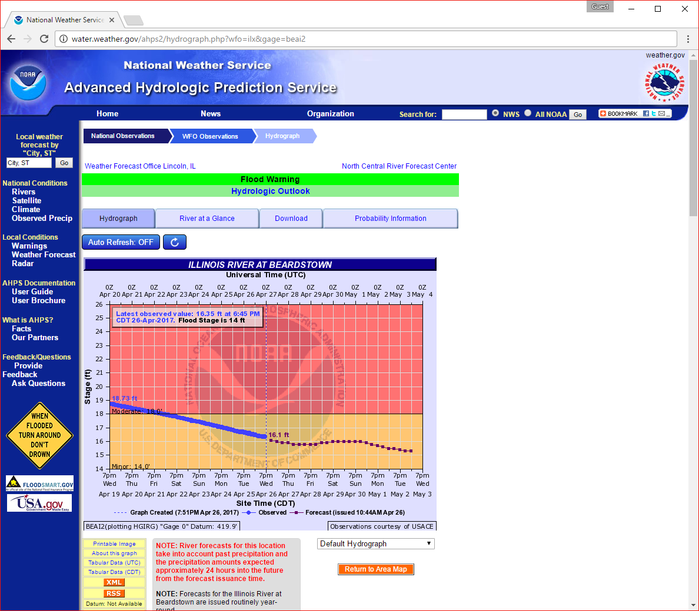

1. Click on the link to the Corps of Engineers (COE) Info.

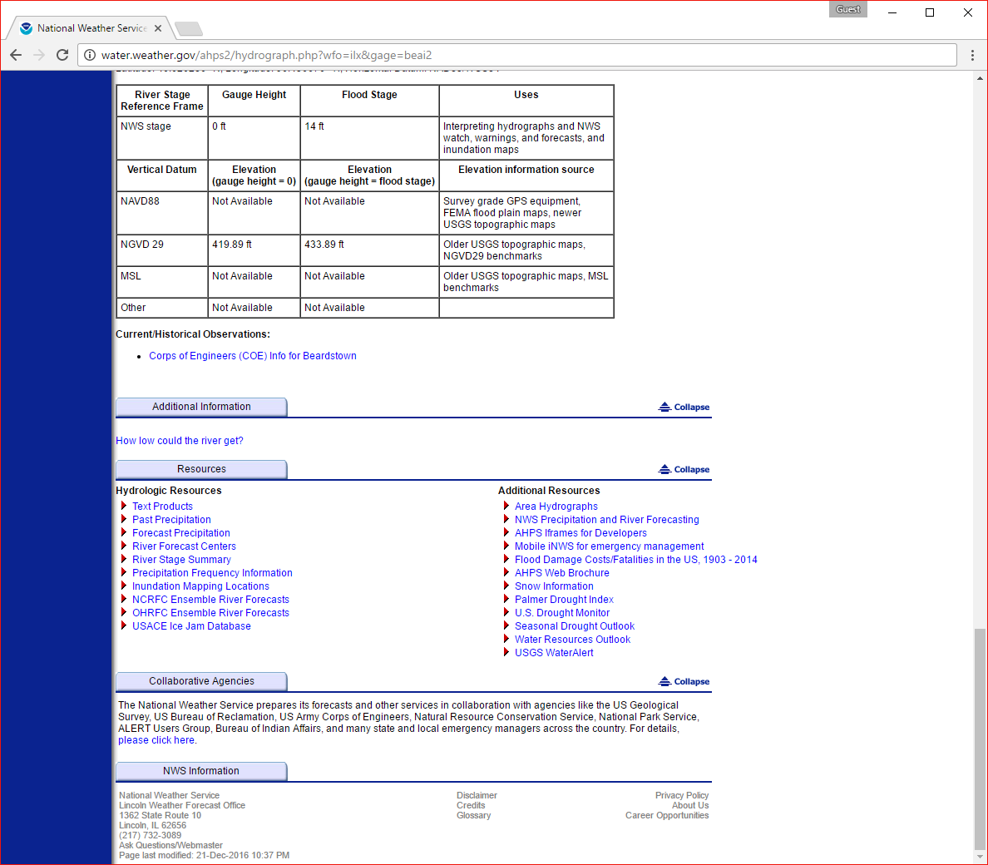

1. Click on redirect link.

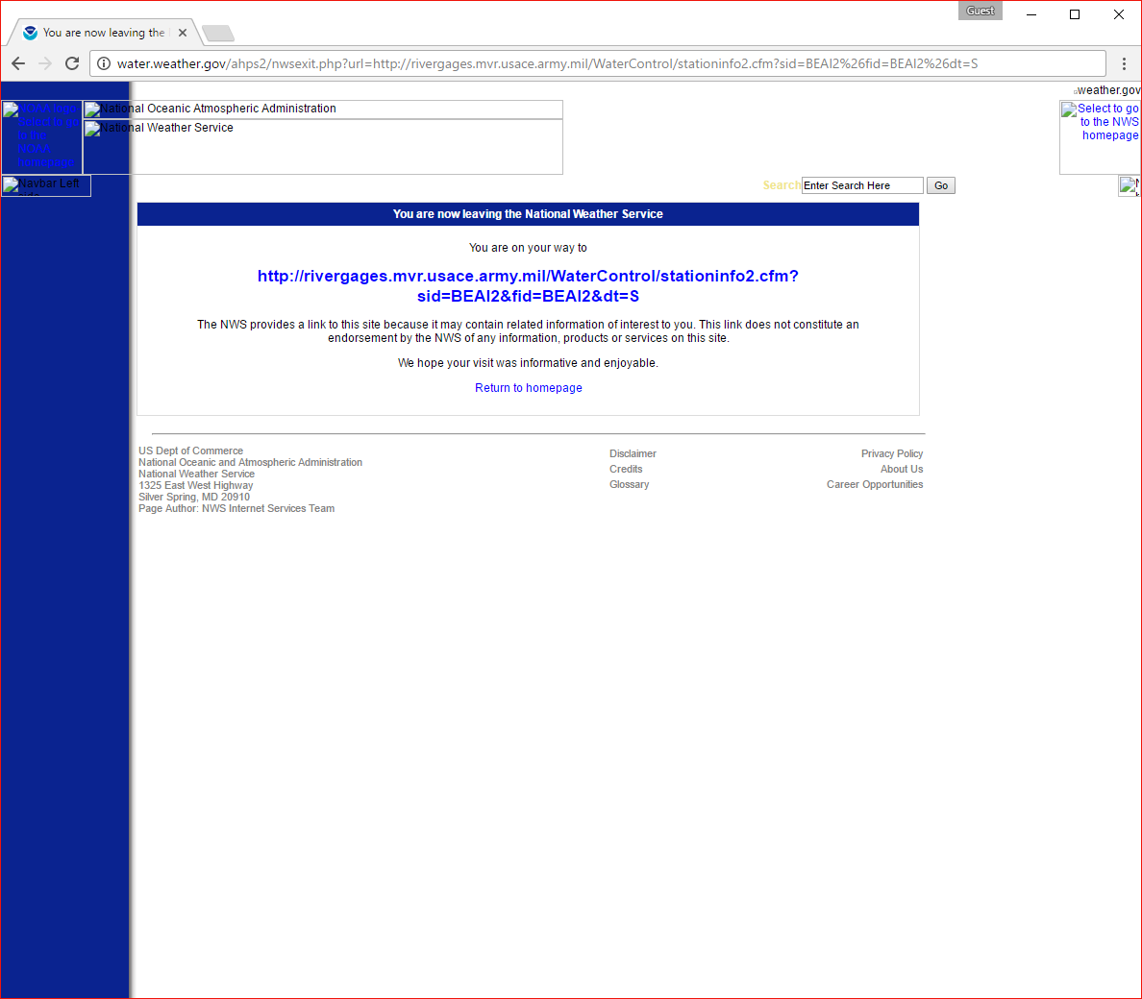

1. In the blue box on bottom right, select HG - Stage (Ft) from the Choose a Parameter dropdown.

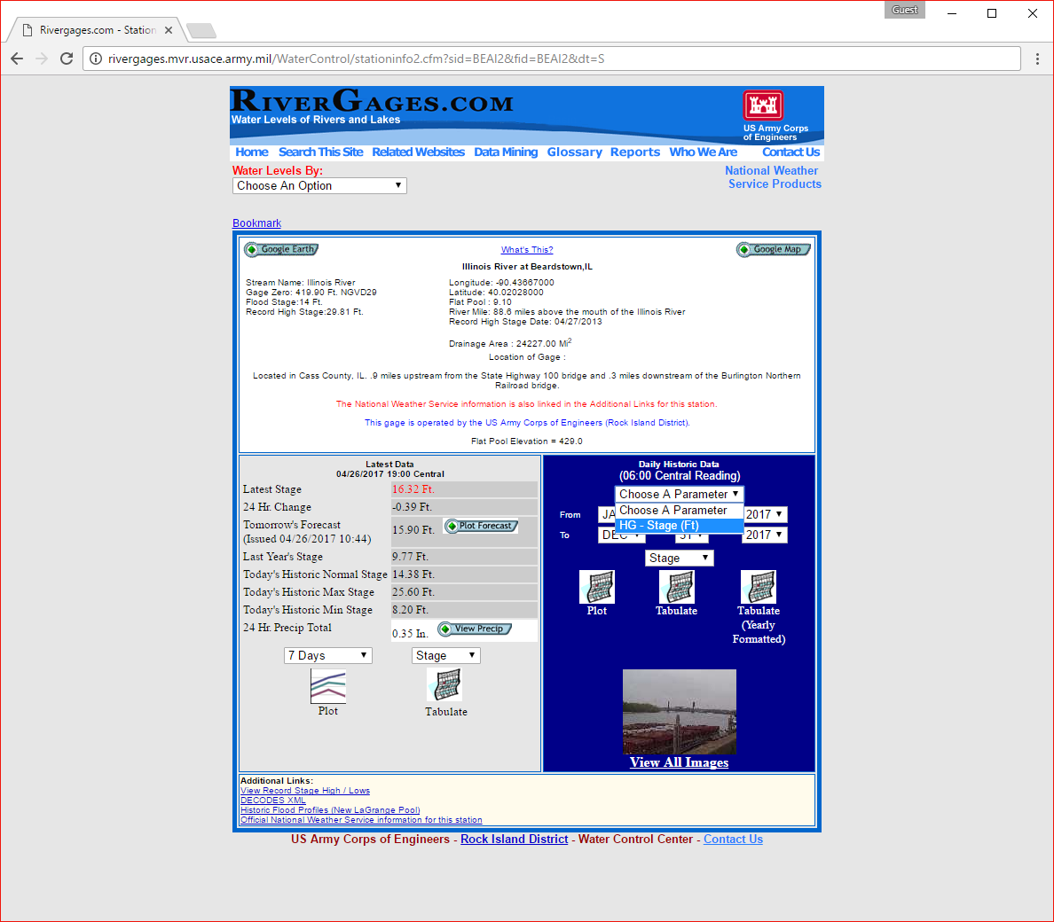

1. Select your desired date range. NOTE: If you forgot to do the previous step, it will reset the date range when you select Stage (Ft).

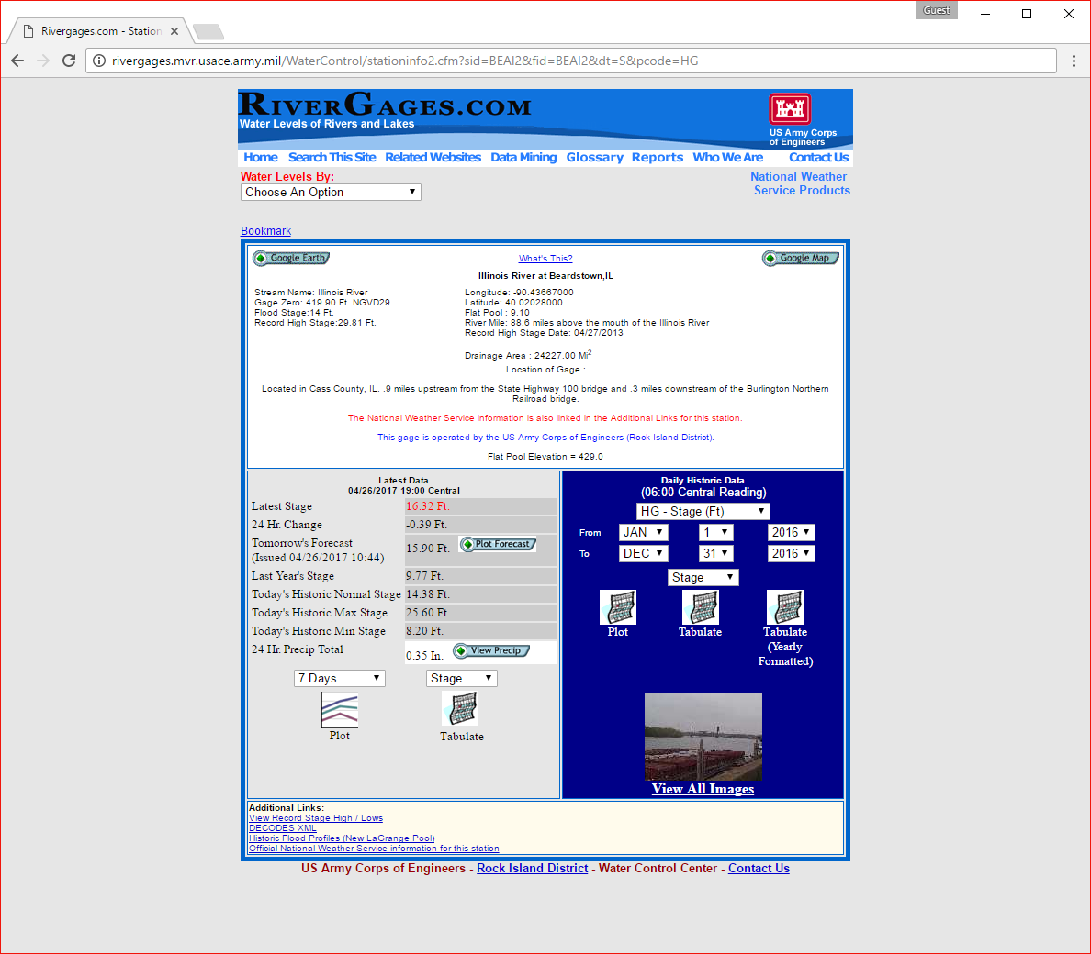

1. Make sure the last dropdown says Stage, NOT ELEVATION.
2. Click Tabluate. The next page may not load instantly, but you do not need to click the link again. DO NOT CLICK THE YEARLY FORMATTED VERSION.
3. Data will be displayed spreadsheet style on a webpage.

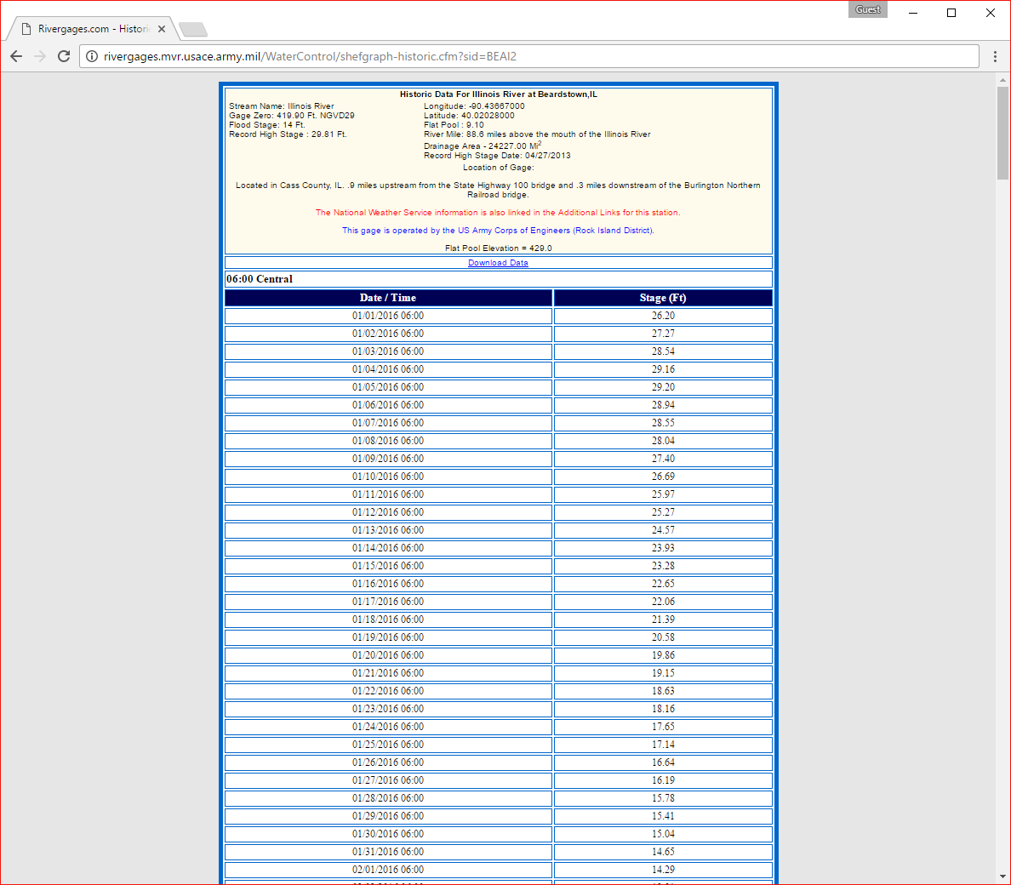

1. Find and click the Download Data link (below the cream colored box).
2. Start a new document in Notepad.
3. Open the downloaded spreadsheet. It will likely be named ShefHistoric.xls
4. You may get the error "The file format and extension of ‘ShefHistoric.xls’ don't match. etc.". Click Yes.

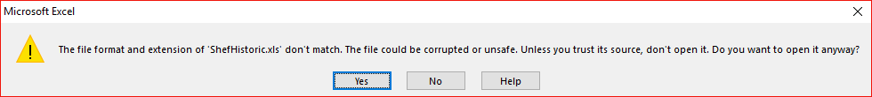

1. You may need to click Enable Editing.

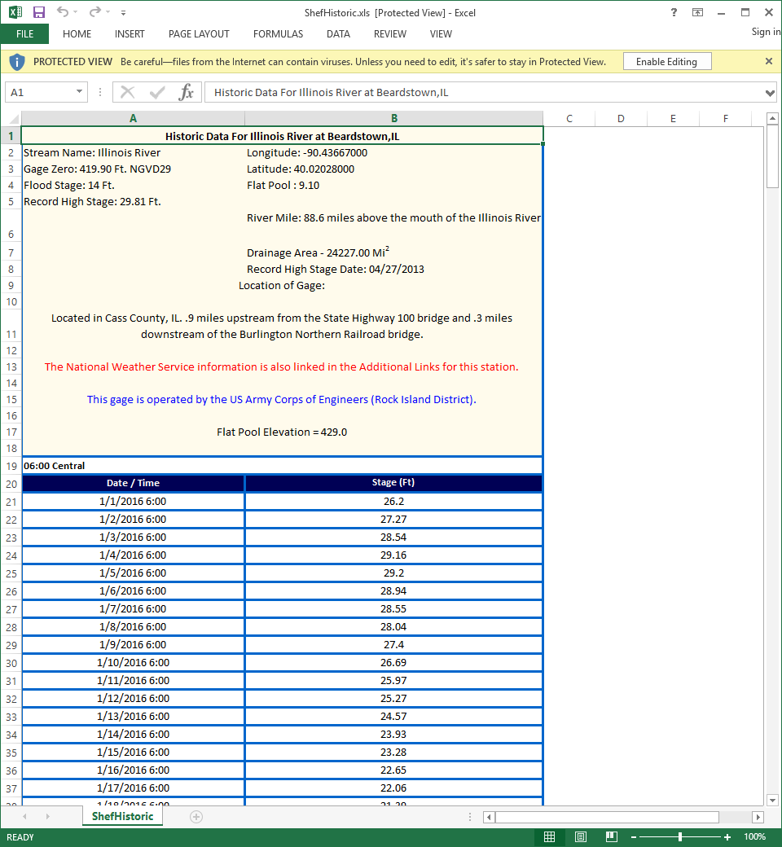

1. Copy all the data and paste it into your new Notepad document.

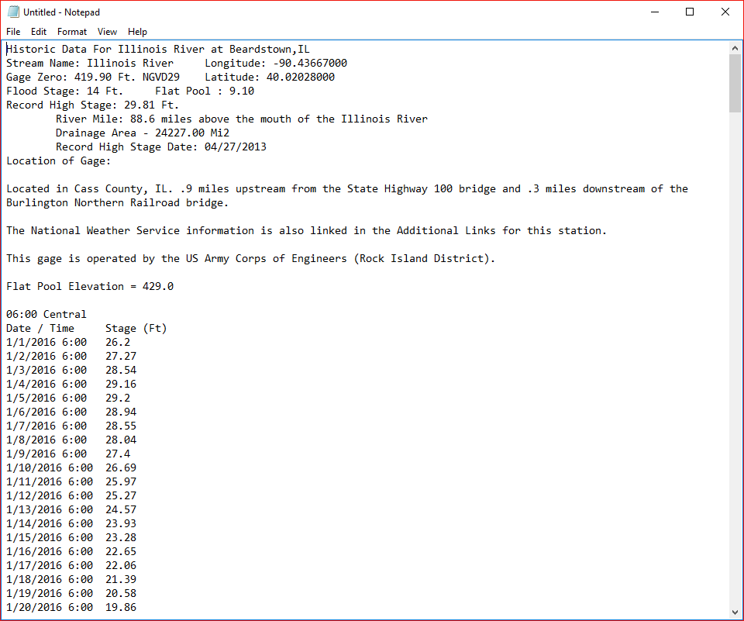

1. Save the Notepad file as a .txt file. Once you have collected all your data, you will upload the .txt files through the visualization tool.

To download data for another river gauge, you may need to return to the beginning of this guide. If you started at one end of your data area, you can click the back button on your browser until you get to the page from Step 4. There you can click on the arrow next to Downstream Gauge or Upstream Gauge.

